**MINI PROJECT**

**(2019-20)**

# NOTESBOG

**SYNOPSIS**



**Institute of Engineering & Technology**

**Submittedto: Submittedby:**

Mr. Sharad Gupta Vaishali Jain

(Assistant Professor) (171500370)

Divyanshu Singh

(171500104)

**ACKNOWLDGEMENT**

It gives us a great sense of pleasure to present the synopsis of the B.Tech Mini Project (NOTESBOG) undertaken during B.Tech IIIrd Year. This project in itself is going to be an acknowledgement to the inspiration, drive and technical assistance will be contributed to it by many individuals.

We owe special debt of gratitude to Mr. Sharad Gupta, Assistant Professor Department of CEA, for providing us with an encouraging platform to develop this project, which thus helped us in shaping our abilities towards a constructive goal and for his constant support and guidance to our work. His sincerity, thoroughness and perseverance is been a constant source of inspiration for us. We believe that he will shower us with all his extensively experienced ideas and insightful comments at different stages of the project & also taught us about the latest industry-oriented technologies.

We also do not like to miss the opportunity to acknowledge the contribution of all faculty members of the department for their kind guidance and co-operation.

Vaishali Jain

(171500370)

Divyanshu Singh

(171500104)

**NOTESBOG**

**(Web Development)**

In this project, I am creating a backend part of the website based on learning material and it will be a web developers site, with tutorials and references on web development language such as HTML, CSS, JavaScript, PHP, SQL, Python, jQuery, Java, Bootstrap, covering most aspects of web programming.

**We have completed the frontend part of the website in previous semester. In this session, our main focus is on the backend part of the website and making the website live on the Internet.**

->The site drives its name from the Notesbog.

->Notesbog has focus on simplicity.

->Notesbog use simple code explanations with simple illustrations of how to use it.

->Notesbog tutorials start from basic level and move all the way up to professional references.

As we faced many problems while studying due to non availability of good content on the particular topic. So, it will be a source to all those problems. Students can learn about a particular topic in this and after studying that topic can solve a practice exercise that will be provided to them at the end of particular topic.

Many sample papers, important point regarding projects based on a particular topic, short tricks to learn will also be provided in this website.

It will be too simple and students friendly.

They will enjoy and enhance their interest while studying from this website.

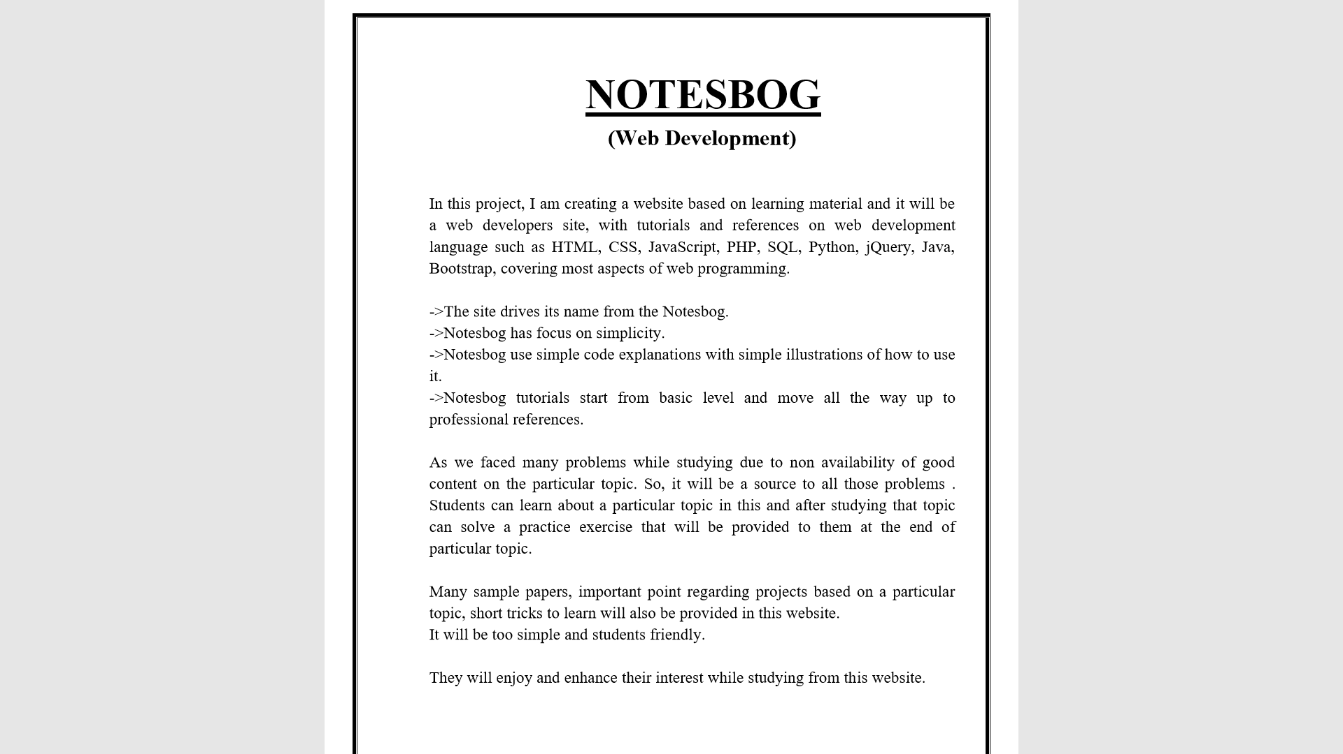

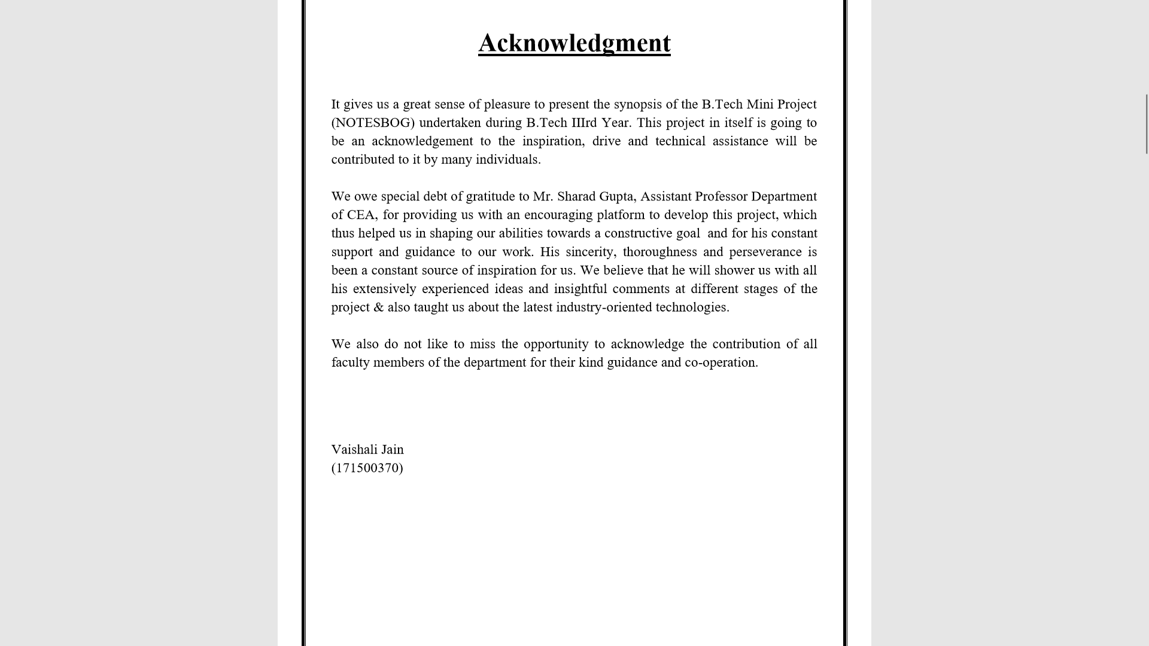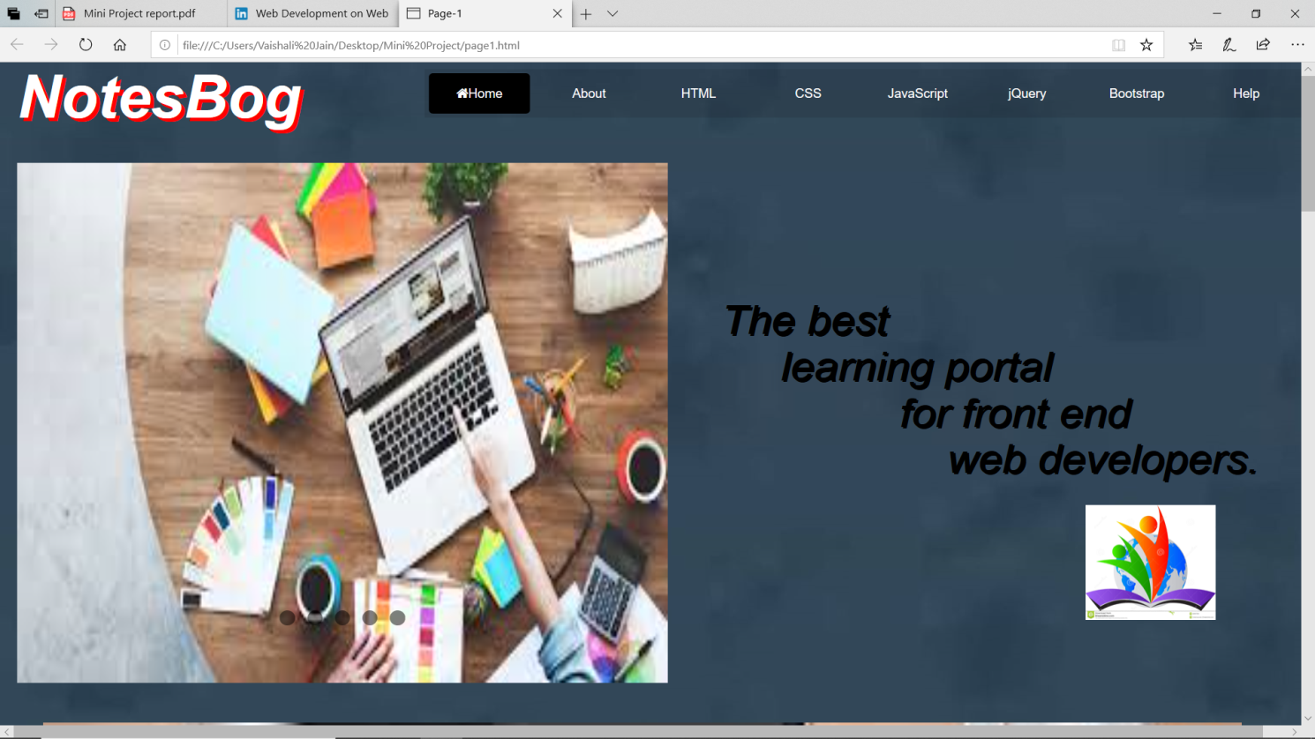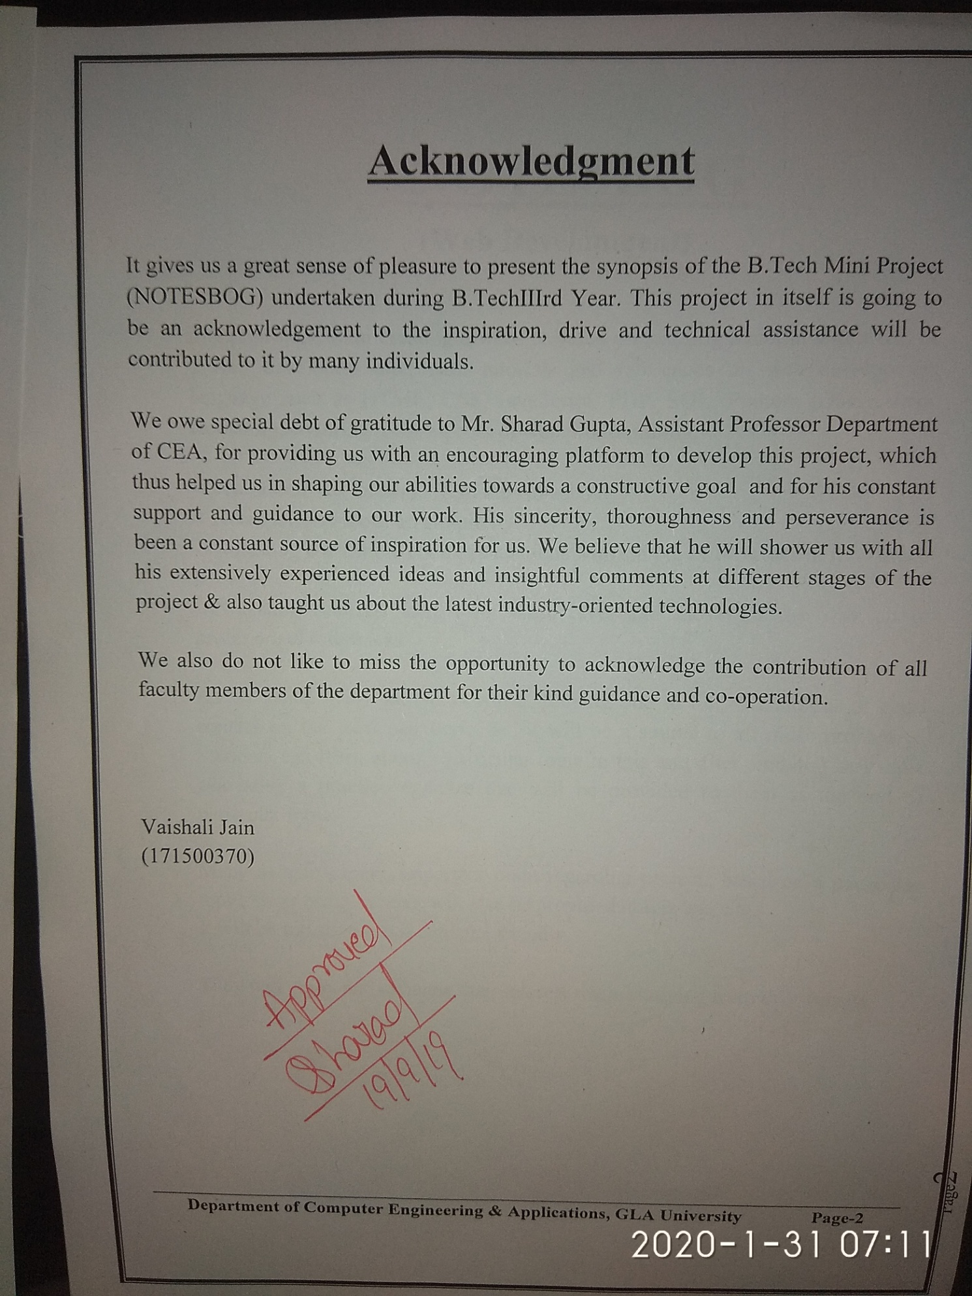

**Contents**

**Abstract…………………………………………………………..…… (i)**

**Declaration……………………………………………………………. (ii)**

**Acknowledgement……………………………………………………. (iii)**

**1. Introduction………………………………………………………... (7)**

1.1 Objective………………………………………………………... (7)

1.2 Motivation………………………………………………………. (7)

1.3 Problem Statement……………………………………………… (7)

**2. Software Requirement…………………………………………….. (8)**

2.1 Functional Requirements……………………………………….. (8)

2.2 Non-Functional Requirements………………………………….. (8)

2.3 Hardware Requirements………………………………………… (8)

2.4 Software Requirements…………………………………………. (8)

**3. Software Design……………………………………………………. (9)**

3.1 Use Case Diagram……………………………………………… (9)

3.2 ER Diagram…………………………………………………….. (9)

3.3 Class Diagram………………………………………………….. (9)

3.4 Data Flow Diagram…………………………………………….. (9)

**4. Software Testing…………………………………………………… (10)**

4.1 Objective of Testing…………………………………………… (10)

**5. Implementation……………………………………………………. (11)**

**6. References………………………………………………………….. (12)**

**Motivation**

Many people say that today’s college students have it easy. All information they need is at their fingertips, so they can easily complete all academic projects after browsing the Internet for a few hours. However, that’s not what happens in reality. The curriculum have become more rigorous than ever, so college students have to think of different ways on increasing their productivity and motivation.

So for that website is being created that will improve their skills of time management, planning, brainstorming, writing, etc.

**Future Prospects**

As we move towards the mid-21st century, it’s indisputable that web design is going to become increasingly important. As people live more and more of their studies online, digital user experiences will be the rock on which almost every big organisation is built.

**Requirements**

1. **Hardware:**

* External Hard Drives or DVDs for Backup
* **Server**
* Apache Tomcat server
* Glass Fish Server
* Internet
* Minimum 2GB RAM
* i3 Processor
* 1024x765 Display

1. **Software:**

* Brackets
* Operating System(Window, Linux)
* **Programming Language**
* JAVA
* **Front End**
* HTML, CSS, JAVASCRIPT, BOOTSTRAP, jQuery
* **Back End**
* DBMS
* My SQL/Oracle

**REFERENCES**

* **Book References**
* Web Engineering Book
* Core Java Book
* [WWW.w3school.com](http://WWW.w3school.com)
* [WWW.javatpoint.com](http://WWW.javatpoint.com)
* [WWW.youtube.com](http://WWW.youtube.com)
* **Faculty Guidelines**
* Mr. Sharad Gupta Sir
* Mr. Pankaj Kapoor Sir
* Mr. Rahul Pradhan Sir
* Mr. Nitin Tyagi Sir